**1)**

Write a program to check if a number is a palindrome number or not

class A1{

public static void main(String S[])

{

int n=1001,a=0,b=0;

int temp=n;

while(n>0)

{

a=n%10;

b=(b*10)+a;

n=n/10;

}

if(b==temp)

System.out.println("PALLINDROME NUMBER");

else

System.out.println("NOT A PALLINDROME NUMBER");

}

}

**OUTPUT**

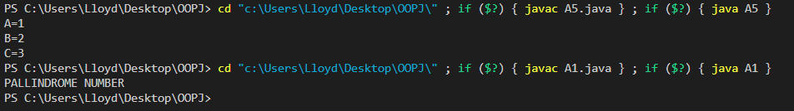

**2)**

Write a program to find sum of digits of a multidigit number

class A2{

public static void main(String S[])

{

int n=1111,sum=0,a;

int temp=n;

while(n>0)

{

a=n%10;

sum=sum+a;

n=n/10;

}

System.out.println("Sum="+sum);

}

}

**OUTPUT**



**3)**

Write a program to create a class called shape, create a default constructor for this class, write overloaded methos to calculate area of different shapes.

class shape{

int l,b;

shape()

{

l=0;

b=0;

}

int area(int l,int b)

{

return(l*b);

}

int area(int l)

{

return(l*l);

}

}

class A3{

public static void main(String S[])

{

shape x=new shape();

System.out.println("AREA OF RECTANGLE="+x.area(2,3));

System.out.println("AREA OF SQUARE="+x.area(2));

}

}

**OUTPUT**



**4)**

Write a program to create a class bicycle which has to attributes, gear and speed, write a parameterized constructor for this class let this class have 3 methos

1) Applybrake: reduces the speed accordingly

2) SpeedUp: Increases the speed accordingly

3) NoOfGreas: display no of gears and the speed

Write another class called mountain bike which extends class bicycle and has a field called seat height, implement a constructor to initiate the 3 parameters also write a method that allows you to set the seat height to a new value

class Bicycle{

int gear;

float speed;

Bicycle(int a, float b)

{

gear=a;

speed=b;

}

void Apply_brake(float a)

{

speed=speed-a;

}

void Speed_up(float a)

{

speed=speed+a;

}

void No_of_gears()

{

System.out.println("NO OF GEARS="+gear+"\nSPEED="+speed);

}

}

class Mountain_bike extends Bicycle{

float Seat_height;

Mountain_bike(float speed,int gear, float seatH)

{

super(gear,speed);

Seat_height=seatH;

}

void setH(float a)

{

Seat_height=Seat_height-a;

}

}

class A4{

public static void main(String S[])

{

Mountain_bike x=new Mountain_bike(5.5f,5,1.2f);

x.Apply_brake(1.0f);

x.Speed_up(3.0f);

x.No_of_gears();

}

}

**OUTPUT**

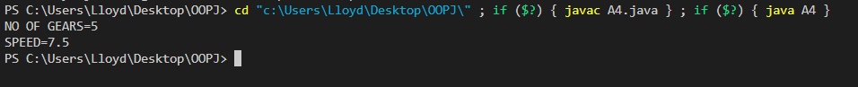

**5)**

Write a program to implement class X which has variable a, write a constructor to initialize this value. Write a class Y which has the variable b and write a constructor to initialize it. Write a class Z which has variable c and write a constructor to initialize it.

class X{

int A;

X(int a)

{

A=a;

}

}

class Y extends X{

int B;

Y(int a,int b)

{

super(a);

B=b;

}

}

class Z extends Y{

int C;

Z(int a, int b,int c)

{

super(a,b);

C=c;

}

}

class A5{

public static void main(String s[])

{

Z obj=new Z(1,2,3);

System.out.println("A="+obj.A);

System.out.println("B="+obj.B);

System.out.println("C="+obj.C);

}

}

**OUTPUT**

